Commercial in confidence

OPTICAL NETWORK TERMINAL (ONT)

UNITS AND POWER SUPPLY INFORMATION

Optical Network Terminal (ONT) units and power supply information
Telstra Velocity is an access infrastructure that delivers integrated telephony. It is only available in selected areas around Australia.
South Brisbane
Details specified below may differ for premises in South Brisbane. Please refer to your Fibre Access Broadband end-user Technical Specifications and On the Day documents for detailed information.
Optical Network Terminal (ONT)
At your end user’s premises, a Telstra Optical Network Terminal (ONT) converts services between optical signals on the access network fibre and electrical interfaces for connection to the end user’s Customer Premises Equipment (CPE) such as analogue phones, Digital RF video set top units and Ethernet devices.
The type of ONT installed by Telstra will be decided at the time of appointment by the Telstra technician. End-users and wholesale customers cannot choose an ONT type.
The Telstra ONT will be supplied as either internal or external units (see indicative photos in Figures 1, 2 and 3 below)*.

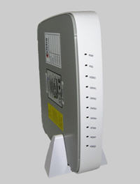 | 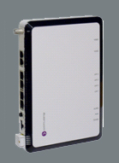 | 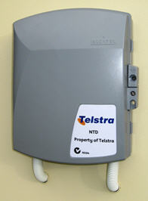
Figure 1. Type A Internal ONT | Figure 2. Type B Internal ONT | Figure 3. External ONT

* actual units may differ.

Power supply
The Telstra ONT is powered from domestic 240 Volt AC power via a separate ONT power supply unit (PSU).
The Telstra PSU is available in different configurations depending on the ONT installed, however all PSU configurations are installed indoors.

Internal ONT
Standard PSU- AC/DC converter similar to laptop computer power supplies. This PSU does not have the capacity to accept a backup battery. See Figure 4*. (NB. This internal ONT is only supplied where the end user or a previous end user chose this PSU type to be installed).
Backup battery-capable PSU - AC/DC converter with a cavity to accept a backup battery. See Figure 6*. (NB: battery to be supplied and maintained by end user).

External ONT
Backup battery capable PSU - AC/DC converter with capacity to accept a backup battery. The PSU is installed indoors and the backup battery must be supplied and maintained by the end user. See Figure 5*.
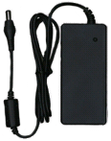 |  | 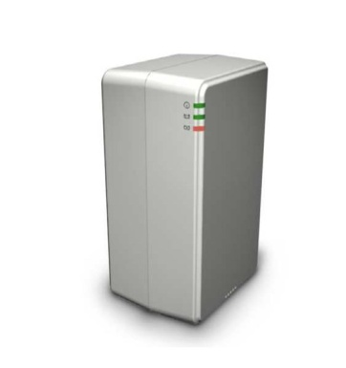
Figure 4.  Standard PSU  for Type A or Type B Internal ONT | Figure 5. Type 1 Battery Backup Capable PSU for External ONT and for  Type A Internal ONT | Figure 1. Type 2 Battery Backup Capable PSU for  Type B Internal ONT

* actual units may differ.

Back-up battery
Basic Telephone Services supplied over Telstra Velocity require a power supply to operate the ONT. Accordingly, in order to use Basic Telephone Services supplied over Telstra Velocity during a power outage, your end user needs:
- a backup battery-capable PSU (i.e., not the “Standard PSU” described above, which is not backup battery capable);
- an operating backup battery; and
- a telephone handset that does not require a power supply to operate.
As noted above, not all PSUs are backup battery-capable. Your end user can determine whether a PSU is backup battery-capable by examining the label on the PSU. PSUs which are backup battery-capable have a label advising customers that their service will not work if there is a power failure, unless there is an operational backup battery. For those PSUs which are not backup battery-capable, the label simply says that the service will not be available in a power failure.
If your end user does not have a backup battery-capable PSU installed, your end user may upgrade to a backup battery-capable PSU at Telstra’s fee-for-service rates.
Backup batteries must be supplied and maintained by the end user. If a battery has been installed, your end user should regularly check the battery indicators and replace the battery as recommended by the manufacturer. During any power outage, the end user will not be able to make or receive a telephone call if the back-up battery is flat or faulty.

Incompatible products
There are some products that are unavailable over Telstra Velocity. These products are listed in section 4.15 of Our Customer Terms.

Fault reporting
You can log faults electronically through Linxonline Service (LOLS) or through the National Wholesale Service Centre via phone using Telstra Wholesale’s processes.

